

Supramolecular Chemistry Applied to Organic Materials: Evidence of New Properties in Health, Electronics, and Battery Innovations
Pr. Nathalie JARROUX
LAMBE, UMR8587 Laboratoire Analyse, Modélisation, Matériaux pour la Biologie et l'Environnement, Université d’Evry Val d’Essonne,
IGPS, Institut Galien Paris Saclay, Université Paris Saclay
After developing the high-yield synthesis of supramolecular assemblies based on polymers and cyclic molecules resembling a necklace, controlling the reaction opens the way to new architectures in terms of morphologies to adapt to different applications.
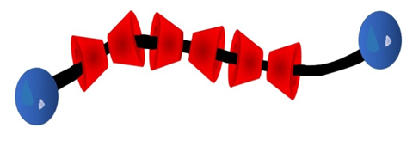

The first polyaminated polyrotaxanes, which are soluble in water and hydrolysable, have been synthetized. A collaboration with the Iasi group in Romania has led to the development of the polyrotaxane synthesis based on conducting polymers such as polyfluorene, polyazométhine.to improve OLED performances.
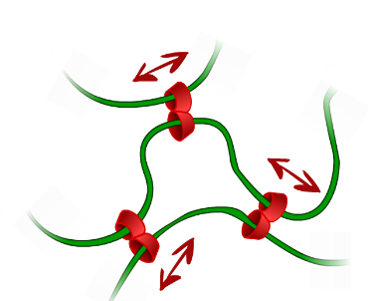
The development of sliding gels based on polyrotaxanes in collaboration with the Japanese company Menicon has resulted in a new polyrotaxane synthesis method, which has been patented. This has led to the creation of new tubes tubes that allow for mechanical stimulation for in vitro fertilization. The using of polyrotaxane gels as coatings with self healing properties has been demonstrated. The control of polyrotaxane synthesis allows for the synthesis of bio-sourced and biodegradable cyclodextrins nanotubes that are non-cytotoxicity which is compatible with many applications. This control has also been evaluated to improve the lifetime of Si-Anode batteries.

A. FARCAS, N. JARROUX, I. GHOSH, P. GUEGAN, W. M. NAU, V. HARABAGIU, Macromol. Chem. Phys. 210, 1440–1449 (2009) « Polyrotaxanes of Pyrene-Triazole conjugated azomethine and α-Cyclodextrin with High Fluorescence Properties »
Brevet (PCT/ JP2013/064968), 2013, « Synthesis of PDMS based polyrotaxane, Purified PDMS based polyrotaxane and PDMS based polyrotaxane derivatives » P; Choppinet, F. Blin, N. Jarroux Exploitation par la société Menicon
H. MAMAD HEMOUCH, H. RAMOUL, M. ABOU TAHA, L. BACRI, C. HUIN, A. OUKHALED, B. THIEBOT, G. PATRIARCHE, N. JARROUX, J. PELTA, Nano Lett., 15 (11), 7748–7754 (2015), «Biomimetic Nanotubes Based on Cyclodextrins for Ion-Channel Applications».
H. MAMAD HEMOUCH, L. BACRI, C. HUIN, C. PRZYBYLSKI, B. THIEBOT, G. PATRIARCHE, N. JARROUX, J. PELTA, Nanoscale, Vol. 10 Issue 32, p15303-15316 (2018), “Versatile cyclodextrin nanotube synthesis with functional anchors for efficient ion channel formation: design, characterization and ion conductance”.
F.BETERMIER, N. DAHER, L. ALBERO BLANQUER, J. BRUN, A. MARCELLAN, N. JARROUX, J-M. TARASCON, Chem. Mater., 35, 937-947 (2023) «Understanding the Electrochemical Performances of Si Anodes Incorporating Mechanically Interlocked Binders Prepared from α-Cyclodextrin-Based Polyrotaxanes»

